C-1
Section: #n
Suggested by: Mikhail Marandyuk
Theme:

Прямой мат в 4 или более ходов. В начальной позиции на поле Х находится белая фигура (не пешка). В процессе решения белая фигура освобождает поле Х, чтобы позволить другой белой фигуре (не пешка) занять то же поле Х. Белая фигура которая занимает поле Х сразу жертвуется (черные должны ее взять). Возможна реализация в одном варианте или более вариантов, стратегическая или логическая игра.

Direct-mates in 4 or more moves. In an initial position on a square X there is a white piece (not a pawn). During the solution the white piece vacates a square X to allow another white piece (not a pawn) to occupy the same square X. The white piece which occupies the vacated square X immediately sacrifices itself there (black must capture it). The realization in one variation or more variations, strategic or logic play is possible.

Example:
M.Marandyuk
1-3 Pr Ural Problemist 2003
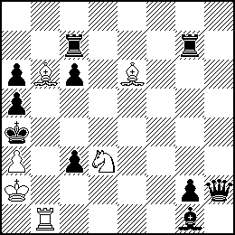
#8 C+ 6+10

1.Lb3+ Kb5 2.a4+? K:b6!
1.Tb6??
1.Lf2? c5! 2.Tb6 c4!
1.Lb3+! Kb5 2.Lf7+ Ka4 3.Lf2 L:f2 4.Lb3+ Kb5 5.Le6+ Ka4
6.Tb6! L:b6 7.Lb3+ Kb5 8.a4#
C-2
Section: #n
Suggested by: Wilfried Neef
Theme:
black (line,field...) vacation sacrifice (in German: schwarze Räumungsopfer).
Of course you have often seen vacation sacrifices, but mostly in white. Black sacrifices are in principle easy to create, and I think this is a wide field!
Examples:

1. Wilfried Neef
1 HM Schach-Aktiv 1998
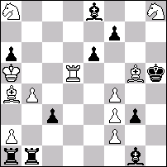
#7 (11+10)
1. Le8:?, Ta2:+!
1. fg3:, Lb6+ 2. Sb6:, Tg1 3. Td2, cd2: 4. Sd5, ed5: 5. Le8:, Ta2:+ 6. Kb6 7. Lf7:#

2. Frank Reinhold  Pr Freie Presse 1991  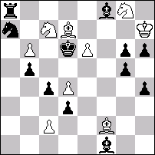  #8 (9+12)  1. Sb5:+?,Sb5:!  1. Le1?, d2! 2. Ld2:, c3 3. Lc3:, Sc6 4. Lb4+, Sb4: 5. c4, Lc4:!  1. Lg1!, g4 2. Le3, g5 3. Ld2, c3 4. Lc3:, Sc6 5. Lb4+, Sb4: 6. c4, bc4: 7. Sb5+, Kd5 8. Sf6#  Black square-vacation sacrifice on d2 avoided | 3. Rolf Trautner  Die Schwalbe 2005 (not yet published)  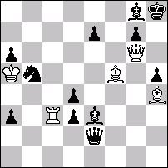  #7 (5+11)  1. Tc8?, Ld2+! 2. Kb6, La5+! 3. Ka5:, Dd2+ 4. Kb6, Dh6!  1. Lf6!, ef6: 2. Tc8, Ld2+ 3. Kb6, La5+ 4. Ka5:, Dd2+ 5. Kb6, Dh6 6. Tg8:+, Kg8: 7. De8#

C-3
Section: #n
Suggested by: Viktor Syzonenko
Theme:
Only those black pieces (pawns) are allowed which make at least one capture of a white piece (pawn) in any phase of the author’s plan.
Explanation:
Each black chess-man on the diagram, including pawns and king, is obliged to make at least one capture of white material in the AUTHOR’S plan. In case the black king does not make any capture of white material, the AUTHOR is forbidden to use movements of the black king in his plan.

Example:
A. d'Orville
Problemes d'echecs, 1842
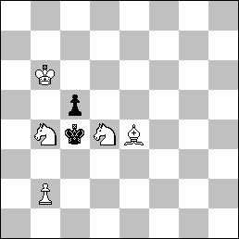
#6 5+2
1.Sbc6 cxd4 2.Sa5+ Kb4 3.Ld3 Ka4 4.Kc5 Kxa5 5.Lb5 d3 6.b4#
C-4
Section: #n
Suggested by: Ukraine
Theme:
Mate in 4 moves: At least 2 variations presenting white piece switchback either to the square it occupied in the diagram position or to a square it previously visited in the course of the play.

L. Larsen
Suomen Shakki, 1993
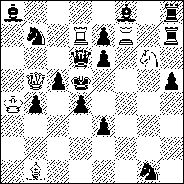
#4 (6+14)

1.Bd3! threat 2.Qc4+ Kc6 3.Se5+ Qxe5 4.Qb5#
1. … Sf3 2.Bc4+ Ke4 3.Rf4+ Qxf4 4.Bd3#
1. … Sa5 2.Sf4+ Ke5 3.Qxc5+ Qxc5 4.Sg6#

